





Phone
Spiinrit
Sistas
s
657-922-6452
Mail
Info@GodGirl.biz
p
m
E
!
s
e
r
u
Address
i
g
r
e
w
o
t
u
f
e
p
a
h
2503 Southern Ave., Box #64252
l
r
s
,
Fayetteville, NC 28306

Dear Parents/Guardians:

Empowering, encouraging, and mentoring our youth is needed. We know this intuitively. We know this through research and through measured outcomes. And we also know that this works best when members of the community come together to invest in the future of their youth.

As you know, our youth need our attention. Latest U.S. Census figures shows that 21.6% of young people under the age of 18 live in North Carolina. Of that percentage, half are at risk of not living up to their potential and could benefit from a relationship with a caring adult mentor. Many of these young people face especially difficult circumstances: one out of four lives with only one parent; one out of 10 born to teen parents; one out of five lives in poverty; and one out of 10 will not finish high school.

Sistas In Spirit is committed to helping these girls become confident and productive adults by empowering them with the skills they need to succeed. To fulfill our commitment, we are working harder than ever to ensure communities have the resources they need to close the mentoring gap – the gap that exists between young people who want and need mentors, and those who are actually in quality mentoring relationships.

Our nation’s schools recognize the need to connect with surrounding communities to support America’s youth. School administrators support the use of volunteer mentors from the community to help students succeed. Experience shows that after spending time with, and getting to know their mentees, adult mentors become true advocates for students.

A growing body of research indicates that mentoring benefits students in number of ways. Students who are mentored show improvement in their school performance, attendance, confidence, attitudes, and relationships with adults (Herrara, Public/Private Ventures, 1999). Mentors positively influence the relationships between mentees and their parents, and as those relationships improve, so, too, do the students’ academic outcomes (Rhodes, Grossman, and Resch, 2000).

Sistas In Spirit looks forward to playing a role in teaching your child that her life has purpose and helping her walk in it.

Warmest regards,
Lisa Harris
Founder, Sistas In Spirit

 L E T T E R
B U S I N E S S C A R D

 P A R E N T H A N D B O O K
S I S I N F O R M A T I O N S H E E T P R I V A C Y P O L I C Y
F I E L D T R I P A N D E X C U R S I O N S P O L I C Y

I , ______________________________________________
( PLEASE PRINT YOUR FULL NAME)
CONFIRM THAT I RECEIVED AND READ THE ABOVE
DOCUMENTION.

I , _______________________________________________
( PLEASE PRINT YOUR FULL NAME)
RETURNED THE SIS INFORMATION FORM , THE LAST PAGE OF THE PARENT HANDBOOK AND THE FIELD TRIP & EXCURSION POLICY TO SISTAS IN SPIRIT .

SIGNATURE: _______________________________________ DATE: _____________________________


Parent Handbook

2503 Southern Ave., Box 64252, Fayetteville, NC 28306
(657) 922-6452
Info@GodGirl.biz
www.GodGirl.biz



Parents & Guardians Handbook


Welcome to Sistas In Spirit (SIS)!
We are delighted to have you and your SIS participant as part of our community. This Parent Handbook is designed to provide you with essential information about our organization's policies, procedures, and expectations. Please take the time to familiarize yourself with its contents and feel free to reach out to us with any questions or concerns.

O V E R V I E W
At Sistas In Spirit (SIS), we believe in fostering a nurturing and stimulating environment where SIS participants can learn, grow, and develop to their full potential. We emphasize the importance of learning, social interaction, and the holistic development of each SIS in our care.

H O U R S O F O P E R A T I O N
SIS will operate during the following hours: Monday to Friday: 9:00 am to 5:00 pm
Saturday: 9:00 am to 12:00 pm (optional, depending on demand) Closed on Sundays and major holidays

E N R O L L M E N T I N F O R M A T I O N
We welcome SIS participants between the ages of 8 - 18 years old to our organization.
To enroll your SIS participant, please complete the enrollment form and all necessary documents required.

The enrollment process includes completing the necessary forms.
We encourage parents to schedule a time to meet our staff and board members.

C U R R I C U L U M A N D A C T I V I T I E S
SIS is designed to promote holistic development in girls. It includes meetings, workshops, outings and other activities that focus on cognitive, social, emotional, and physical development.

H E A L T H A N D S A F E T Y P O L I C I E S
SIS maintains rigorous health and safety standards to ensure the well-being of all SIS participants in our care.
Please refer to our detailed Health and Safety Policies section for information on illness management, emergency procedures, hygiene practices, and our allergy-aware environment.

C O M M U N I C A T I O N A N D I N V O L V E M E N T
We value open communication and encourage parents to actively participate in their SIS participant’s learning journey. Our staff/volunteers will provide updates on your SIS participant’s progress, activities, and any important announcements through reports, newsletters, and scheduled
parent/guardian meetings. Follow us on social media for the lastest news as well.
Facebook Sistas In Spirit

F E E S A N D P A Y M E N T P O L I C I E S
There are no fees associated with Sistas In Spirit (SIS). However, parents/guardians will be responsible for reimbursing SIS for any payments made on behalf of their SIS participant who does not attend a function that required payment in advance.

G U I D E L I N E S F O R D R O P - O F F A N D P I C K - U P
To ensure the safety of all SIS participants, parents/guardians must sign in and sign out their SIS participant upon arrival and departure. There will be NO exception unless the SIS participant is 18 years old.
Please notify us in advance if someone other than the authorized person will be picking up your SIS participant.
ID will be required.

G U I D E L I N E S F O R P E R S O N A L B E L O N G I N G S
Each SIS participant is responsible for any personal belongs brought to the meetings, workshops, outings, etc.
SIS is NOT responsible for any belongs that are stolen, lost or damaged.

P A R E N T I N V O L V E M E N T O P P O R T U N I T I E S
SIS encourages parents/guardians to participate in special events, celebrations, and volunteer opportunities within the organization. Please refer to our Event Calendar for upcoming activities on our website at www.SistasInSpirit.org You can sign up for our electronic newsletter as well.

T E R M I N A T I O N P O L I C Y
Either party may terminate the agreement with Sistas In Spirit (SIS) with a written notice to the other party.
Non-compliance with the organization's policies and procedures may result in immediate termination.

We hope that this Parent Handbook provides you with all the necessary information about our organization. We look forward to a meaningful and collaborative partnership in nurturing and supporting your SIS participant's growth and development.
Please sign the acknowledgment form at the end of this handbook to indicate that you have read, understood, and agreed to the policies and procedures outlined herein.

Sincerely, Lisa J. Harris, CEO

Health and Safety Policies

Health and Hygiene Practices:
- All volunteers/staff members will adhere to strict hygiene practices, including regular handwashing, sanitization of surfaces and equipment, and the use of gloves when handling any food that is not prepackaged or dealing with bodily fluids.
- SIS participants will be encouraged and assisted in maintaining good hygiene habits.

Illness and Medical Care:
- Any SIS participant displaying symptoms of illness, such as fever, vomiting, or contagious conditions, is asked to please refrain from attending any meetings, workshops or outings. If a SIS participant becomes ill while at a function a parent/guardian will be contacted for immediate pick-up.
- SIS will maintain updated records of each child's medical history, allergies, and any required medications, ensuring that all staff members/volunteers are aware of and can respond appropriately to any medical needs.

Emergency Preparedness:
- SIS will conduct regular emergency drills to prepare for various scenarios, including fire evacuations, lockdown procedures, and natural disasters.
- Staff members/volunteers will be trained in first aid and CPR, and first aid kits will be readily accessible and regularly checked to ensure they are well-stocked and up to date.

Safe Environment:
For SIS participants, safety is a top priority, ensuring that each girl feels protected and supported in all program activities. By fostering a secure and respectful environment, we help participants make informed decisions, practice safe behaviors, and navigate challenges both online and offline with confidence and awareness.

Nutrition and Allergies:
- There will be times when SIS will provide nutritious meals and snacks, taking into account any dietary restrictions or food allergies that participates may have. In this case, SIS will share with parents/guardians to ensure transparency.
- Any known allergies of the participants will be prominently displayed in a notebook, and staff/volunteers will be trained to recognize and respond to allergic reactions.

Medication Administration:
- The administration of any required medication will follow strict protocols, including obtaining written consent from the parent/guardian, ensuring proper storage, and maintaining accurate records of administration.

Supervision and Child Safety:
- Staff members will maintain constant supervision of all participants to prevent accidents and ensure their safety during their time with SIS.
- A strict sign-in and sign-out policy will be implemented to ensure that only authorized individuals are allowed to pick up participants from SIS.

Acknowledgment Form

I, acknowledge that I have received and reviewed the Parent Handbook provided by Sistas In Spirit (SIS). I have read and understood the policies, procedures, and expectations outlined in the handbook, and I agree to abide by them during my SIS participant's enrollment with the organization.

I understand that the information provided in the Parent Handbook is essential for ensuring the safety, well-being, and development of my SIS participant while in the care of SIS. I also recognize that any failure to comply with the policies and procedures may result in the termination of my SIS participant's enrollment.

By signing below, I affirm my commitment to working collaboratively with the staff at Sistas In Spirit (SIS) to provide the best possible care and educational experience for my child.

Parent/Guardian's Name:
SIS Participant’s Name:
Date:

Please sign and date the acknowledgment form and return it to the SIS staff to confirm your understanding and agreement with the policies and procedures outlined in the Parent Handbook.

Thank you for your cooperation and support in creating a safe, nurturing, and engaging environment for all SIS participants.

Sincerely, Lisa J. Harris, CEO


SIS Information Form

SIS Participant's Personal Information

Full Name of SIS:
Date of Birth:
Home Address:

Parent/Guardian's Names:
Contact Numbers (Home, Work, Cell):

Email Address:
Emergency Contact (Name and Phone Number):

Preferred Hospital/Clinic:

SIS Participant's Medical Information:
Pediatrician's Name and Contact Information:

Known Allergies (if any, please specify):

Medications (if any, please specify dosage and frequency):

Existing Medical Conditions (if any, please specify):

Additional Information:
Specific Behavioral or Learning Needs:
Other Important Information or Instructions:
Dietary Restrictions or Special Dietary Needs:

Authorized Pick-up Persons:

ID will be required!

Name: Relationship to SIS Participant Contact Number:
Name:
Relationship to SIS Participant:
Contact Number:
Name:
Relationship to SIS Participant: Contact Number:

Photography Consent:
I hereby give consent for photographs of my SIS Participant to be taken for educational or promotional purposes related to the program at Sistas In Spirit (SIS).

Parent/Guardian's Signature:
Date:

Please ensure that all sections of the SIS Participant Information Form are completed accurately and comprehensively.
The information provided will be kept confidential and used solely for the purpose of ensuring the safety, well-being, and appropriate care of your SIS participant during their time at SIS.

Thank you for your cooperation and support in providing us with the necessary information to create a nurturing and secure environment for your SIS participant.

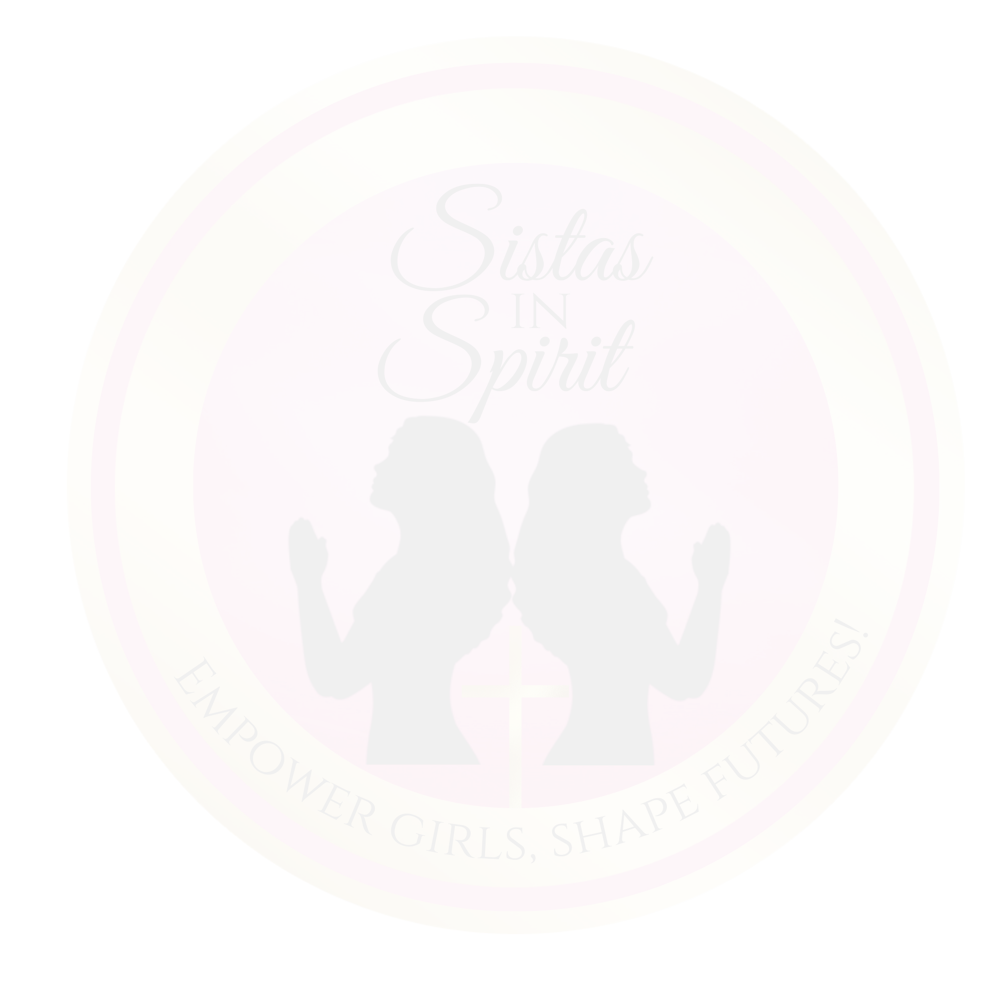

Privacy Policy

Sistas In Spirit (SIS) ("we," "our," or "us") is committed to protecting the privacy and security of your personal information. This privacy policy outlines how we collect, use, disclose, and safeguard your personal information when you use our services.

INFORMATION WE COLLECT
We may collect the following types of personal information from individuals, including but not limited to:
Name
Contact information (address, email, phone number) Emergency contact information
Child-related information (health information, allergies, special needs) Employment information (for staff members)
Donor payment information

HOW WE USE YOUR INFORMATION
We use the collected information for the following purposes:
To provide services and maintain a safe and secure environment.
- To communicate with parents and guardians regarding their SIS participant's well-being, progress, and any important updates.
- For administrative and billing purposes.
- To ensure the health and safety of SIS participants in our care.
- For employment-related and volunteer-related purposes.

HOW WE PROTECT YOUR INFORMATION
We implement reasonable security measures to protect your personal information from unauthorized access, disclosure, alteration, and destruction. Access to personal information is restricted to authorized personnel only.

SHARING OF INFORMATION
We may share personal information with third parties under the following circumstances:
- With your consent.
- To comply with legal obligations.
- In the case of a medical emergency, information may be shared with medical professionals and emergency services.

YOUR RIGHTS AND CHOICES
You have the right to:
- Review and request corrections to your personal information.
- Object to the processing of your information for certain purposes.
- Withdraw consent at any time, where applicable.

RETENTION OF INFORMATION
We will retain personal information for the period necessary to fulfill the purposes outlined in this privacy policy unless a longer retention period is required by law.

CHANGES TO THIS PRIVACY POLICY
We may update this privacy policy from time to time. Any changes will be effective when posted, and the "last updated" date will be revised accordingly. We encourage you to review this policy periodically.

CONTACT US
If you have any questions or concerns about this privacy policy, please contact us at Support@SistasInSpirit.com or (910) 391-7215.

Field Trips and Excursions Policy

P U R P O S E

The Field Trips and Excursions Policy at Sistas In Spirit (SIS) outlines the procedures, guidelines, and responsibilities related to off-site outings with SIS participants in our care. This policy is designed to ensure the safety, security, and well-being of the SIS participants during these activities.

P E R M I S S I O N A N D C O N S E N T
- Parental Consent: Prior to any field trip or excursion, written permission will be obtained from the parent/guardian of each SIS participant.
- Emergency Contact Information: SIS will maintain a list of emergency contact information for each SIS participant, including parents' contact details, authorized adults for pick-up, and any pertinent medical information.

S T A F F Q U A L I F I C A T I O N S
- Supervision: A sufficient number of qualified staff members will accompany the SIS participants on all field trips.
- First Aid Training: At least one staff member/volunteer with current first aid training and CPR certification will be present during the trip.

P L A N N I N G A N D P R E P A R A T I O N
- Trip Itinerary: A detailed itinerary for each trip will be provided to parents/guardians in advance, including departure and return times, location details, and activities planned.
- Transportation: Safe and reliable transportation will be arranged for each trip. All vehicles used will be properly maintained, insured, and operated by licensed drivers.
- Supplies: Staff members/volunteers will carry a first aid kit, emergency contact information, and any necessary medications for SIS participants with medical conditions.
- Identification: SIS participants and staff members will wear identification badges or tags with emergency contact information during the trip.

B E H A V I O R A N D S A F E T Y
- Behavior Expectations: SIS participants will be briefed on behavior expectations before the trip. Respectful behavior towards others, following instructions, and staying with the group will be emphasized.
- Buddy System: SIS participants will be assigned buddies or groups with a designated staff member/volunteer for supervision.
- Emergency Procedures: Staff members/volunteers will review emergency procedures with SIS participants before the trip, including what to do in case of separation, injury, or emergency.

I N C I D E N T R E P O R T I N G
- Documentation: Any incidents or accidents during the trip will be documented immediately by staff members/volunteers. Parents/guardians will be notified promptly.

- Follow-Up: SIS will follow up with parents/guardians and provide incident reports detailing the nature of the incident and any actions taken.

S P E C I F I C R E Q U I R E M E N T S
- Water Safety: For water-related excursions, SIS participants will wear appropriate flotation devices and be supervised by qualified lifeguards.
- Outdoor Activities: For outdoor trips, sunscreen, hats, and appropriate clothing is recommended. Staff/volunteers will ensure hydration and shade breaks.

C A N C E L L A T I O N O R C H A N G E S
- Weather Conditions: Trips may be canceled or rescheduled in case of inclement weather or unsafe conditions.
- Parent Notification: Parents/guardians will be notified of any changes to the trip schedule as soon as possible.

A G R E E M E N T
By signing below, the Parent acknowledges that they have read, understood, and agree to the terms and conditions outlined in this Field Trips and Excursions Policy.
Parent/Guardian Signature:
Date:
SIS Participant’s Name:

